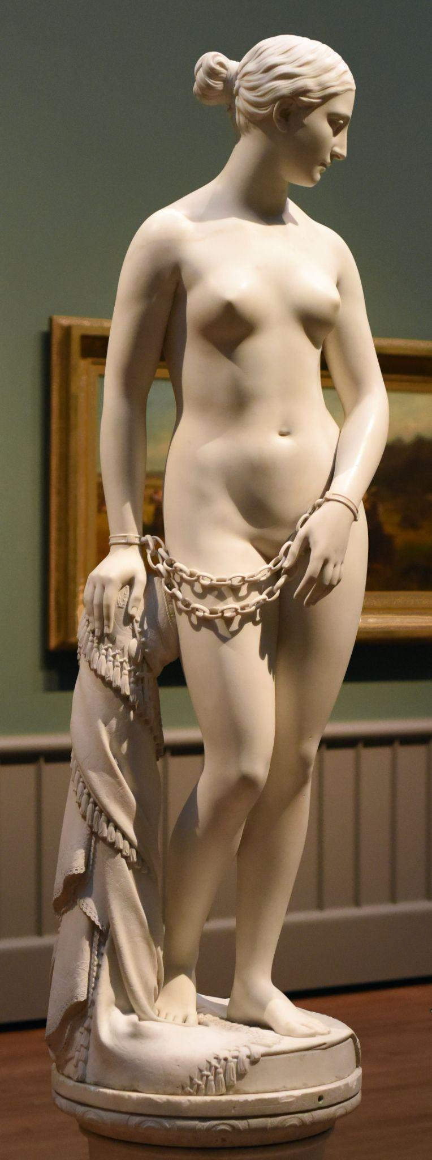

Image of Hiram Powers’ “Greek Slave,” as photographed by Karl Thomas Moore, licensed under the Creative Commons Attribution-Share Alike 4.0 International license.

Hiram Powers’ “Greek Slave”

By Elizabeth Barrett Browning

# 

# Hiram Powers’ “Greek Slave”

By Elizabeth Barrett Browning (1806 - 1861)

They say Ideal beauty cannot enter

The house of anguish. On the threshold stands

An alien Image with enshackled hands,

Called the Greek Slave! as if the artist meant her

(That passionless perfection which he lent her,

Shadowed not darkened where the sill expands)

To so confront man's crimes in different lands

With man's ideal sense. Pierce to the centre,

Art's fiery finger! and break up ere long

The serfdom of this world. Appeal, fair stone,

From God's pure heights of beauty against man's wrong!

Catch up in thy divine face, not alone

East griefs but west, and strike and shame the strong,

” by thunders of white silence, overthrown.

# [Further Information about the Artwork:](https://www.nga.gov/collection/art-object-page.166484.html)

**Artist/Maker:** Hiram Powers (American, 1805-1873)

**Date:** 1869

**Medium:** Seravezza marble

**Dimensions:** 167.5 × 51.4 × 47 cm (65 15/16 × 20 1/4 × 18 1/2 in.)

**Resides In:** The National Gallery of Art, Washington D.C.

Creative Commons License

This work is licensed under a [Creative Commons Attribution 4.0 International License](http://creativecommons.org/licenses/by/4.0/).